**Bug Report Documentation**

**BugID:** CA_001

**Summary priority: high severity: major**

AM_CA_009 – Create Account Page – User is able to enter numeric characters in the name field

**Description –**

Tested in QAT environment - <https://www.amazon.in/>

**Issue:** Namefield accepts numeric characters also

**Steps to be followed:**

1. Open the website
2. Click on the hamburger menu
3. Click on the sign in button
4. Click on the create account button
5. Enter numeric characters in the name field

**Expected:** Name field should not accept numeric characters

**Actual:** Name field accepts numeric characters

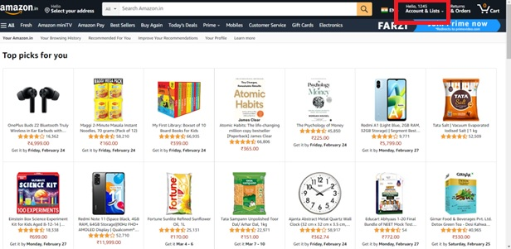

**Labels:** CreateAccount01

**Assign:** Developer

**BugID:** CA_002

**Summary priority: low severity: enhancement**

AM_CA_005 – Create Account Page – User is not able to re-enter the password

**Description –**

Tested in QAT environment - <https://www.amazon.in/>

**Issue:** Re-enter password field is not present

**Steps to be followed:**

1. Open the website
2. Click on the hamburger menu
3. Click on the sign in button
4. Click on the create account button
5. Check for the re-enter password field

**Expected:** Name field should not accept numeric characters

**Actual:** Name field accepts numeric characters

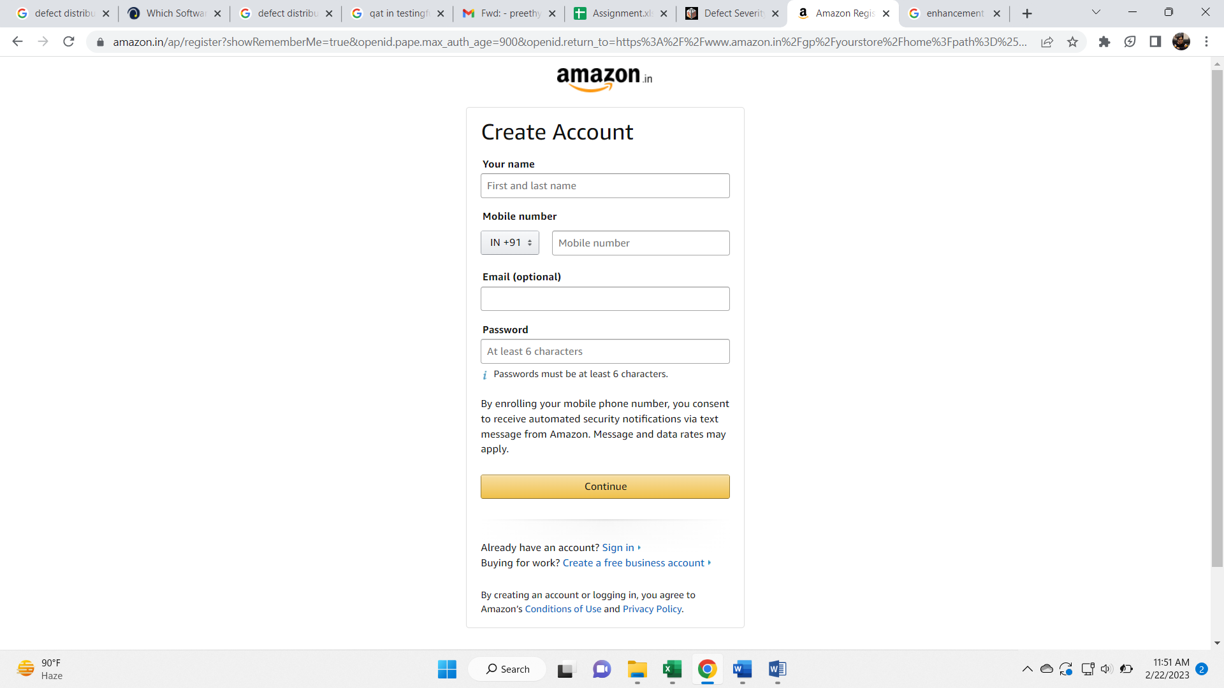

**Labels:** CreateAccount02

**Assign:** Developer